Homework#1 Ansible

Group Name: **Code Ninjas**

Group Members:

Mayuri Bhise

Indrayani Bhalerao

Rashmi Sarode

Sneha Patil

1. 2 EC2 instances were created on AWS

|  |  |  |
| --- | --- | --- |
|  | **Server** | **Client** |
| **Private IP** | 172.31.38.60 | 172.31.47.135 |
| **Public hostname** | ec2-18-188-238-175.us-east-2.compute.amazonaws.com | ec2-3-19-208-144.us-east-2.compute.amazonaws.com |

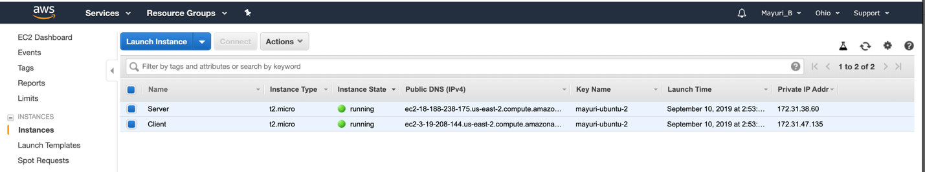

1. Open port 80 for HTTP

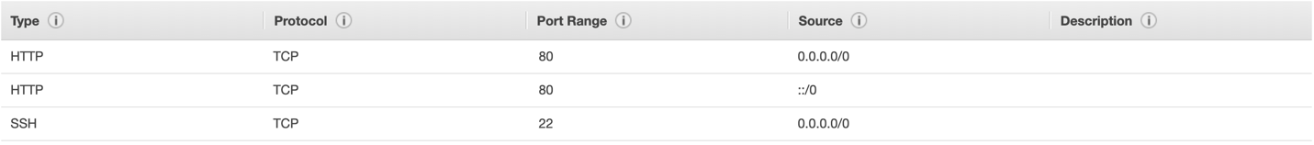

1. Connecting to the AWS instances through AWS console.

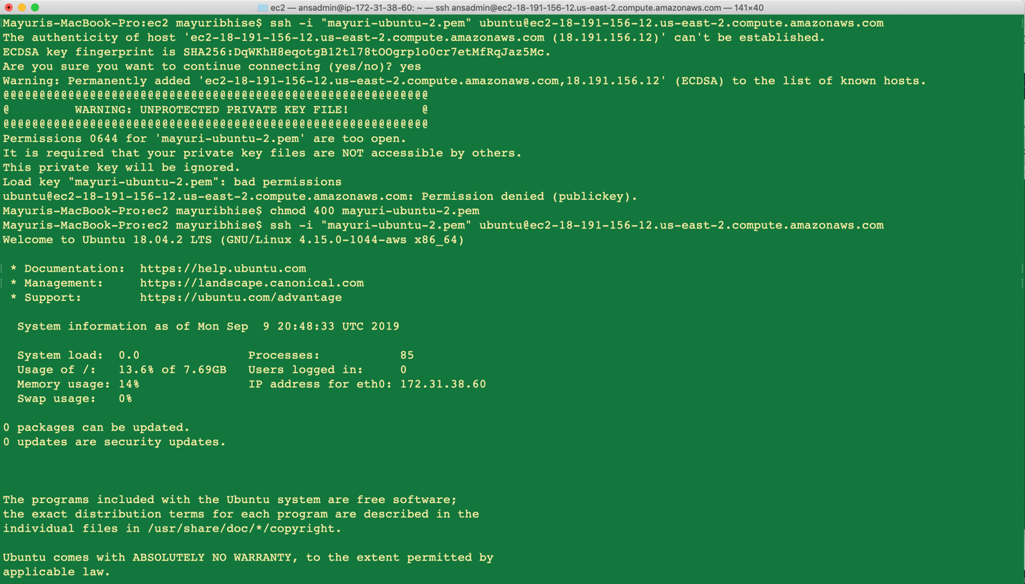

1. Add Ansible repository

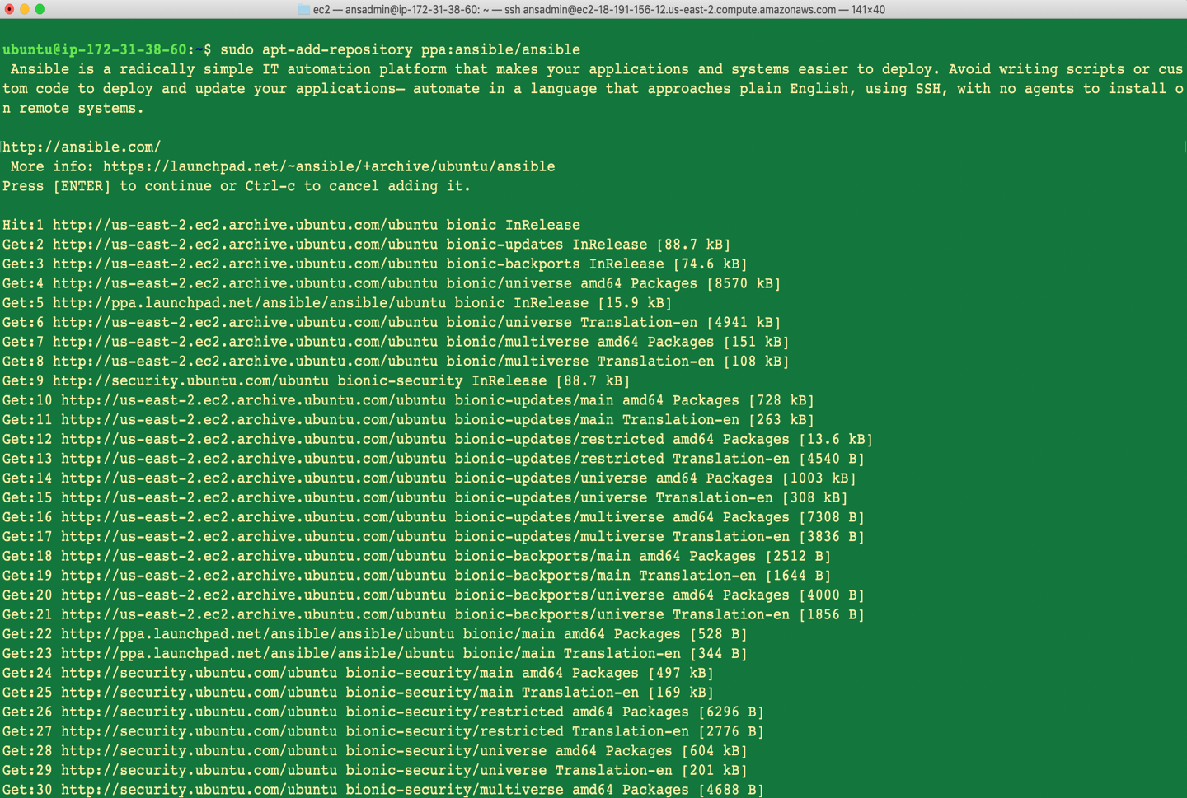

1. Update to get latest version of ansible



1. Install Ansible on Server

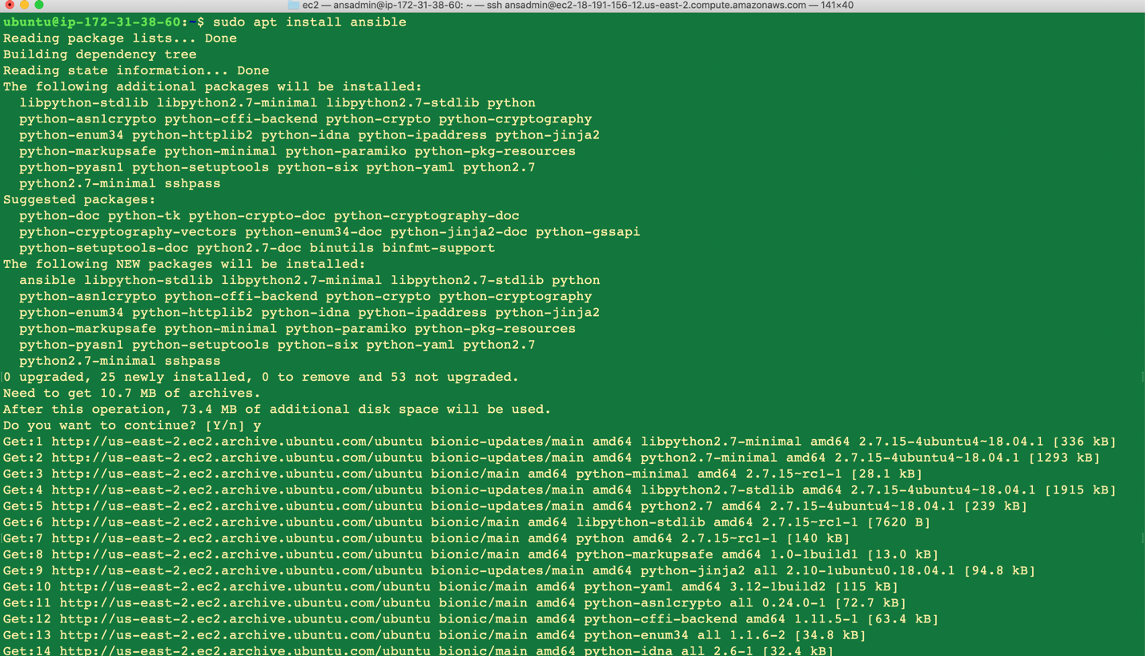

1. Check ansible version



1. Add ansadmin user



1. Change sudoers file to give admin rights to ansadmin user and set NOPASSWD: ALL





1. Change sshd config file, set password authentication to yes and restart service





1. Log in as ansadmin on Server (ssh into Server)

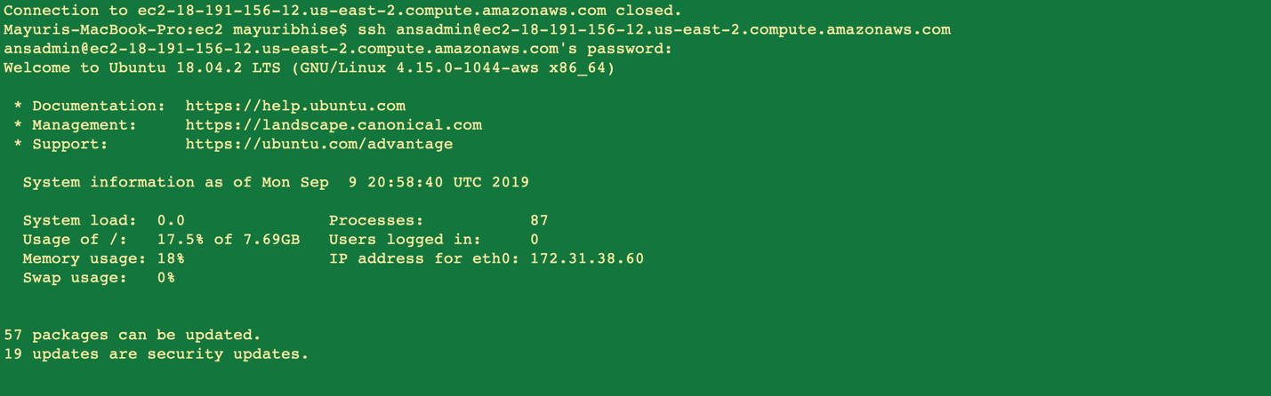

1. Generate key by command ssh-keygen and pass public key to client to establish trust

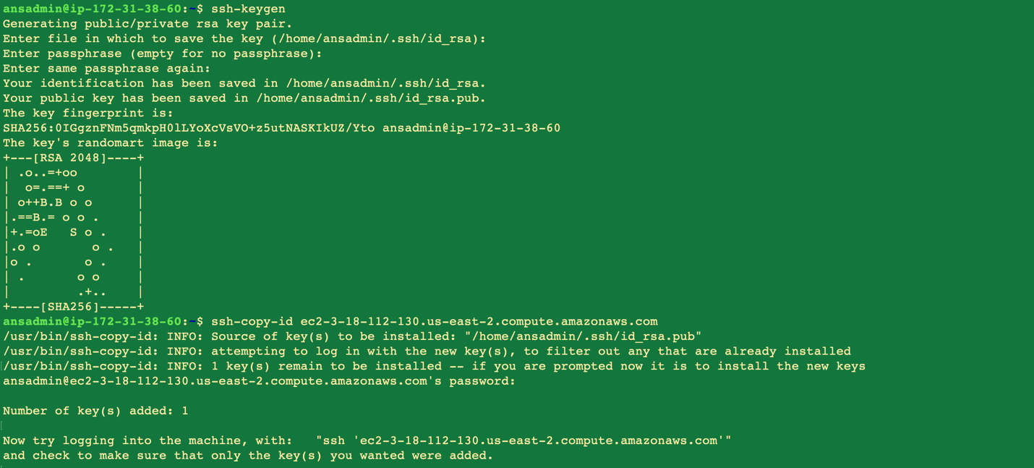

1. Check if ansadmin user can ssh to client without password

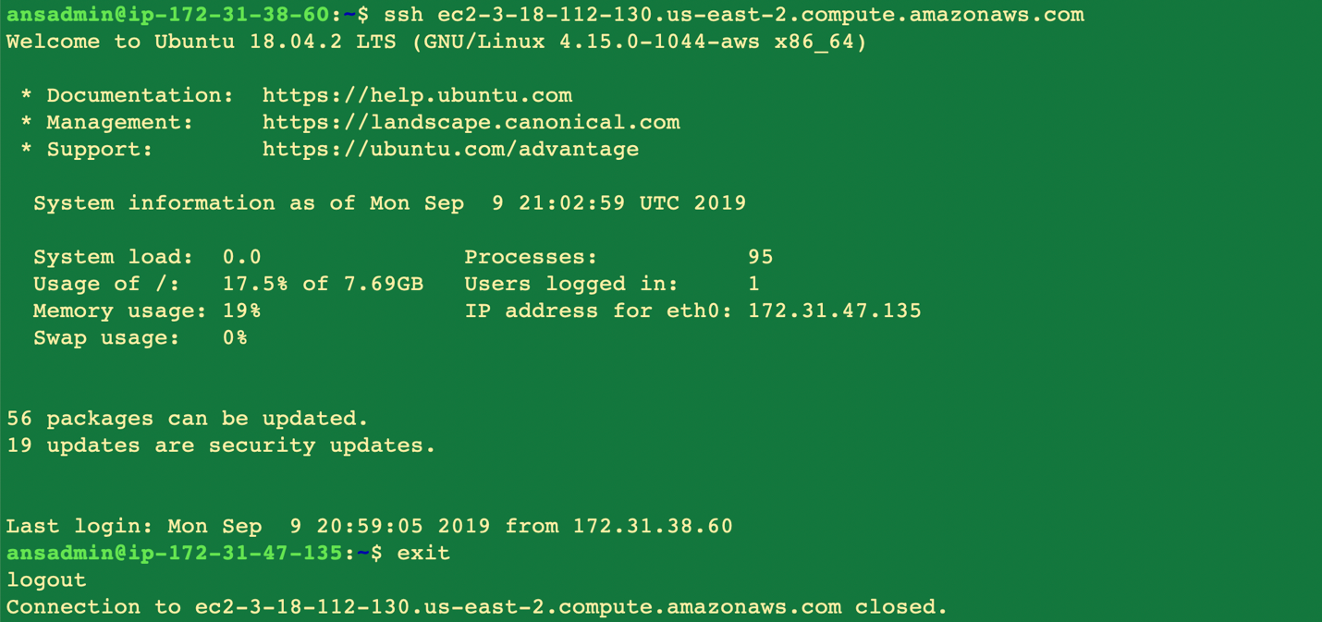

1. Configure Ansible to had client IP is hosts list

  


1. Check if server can reach clients

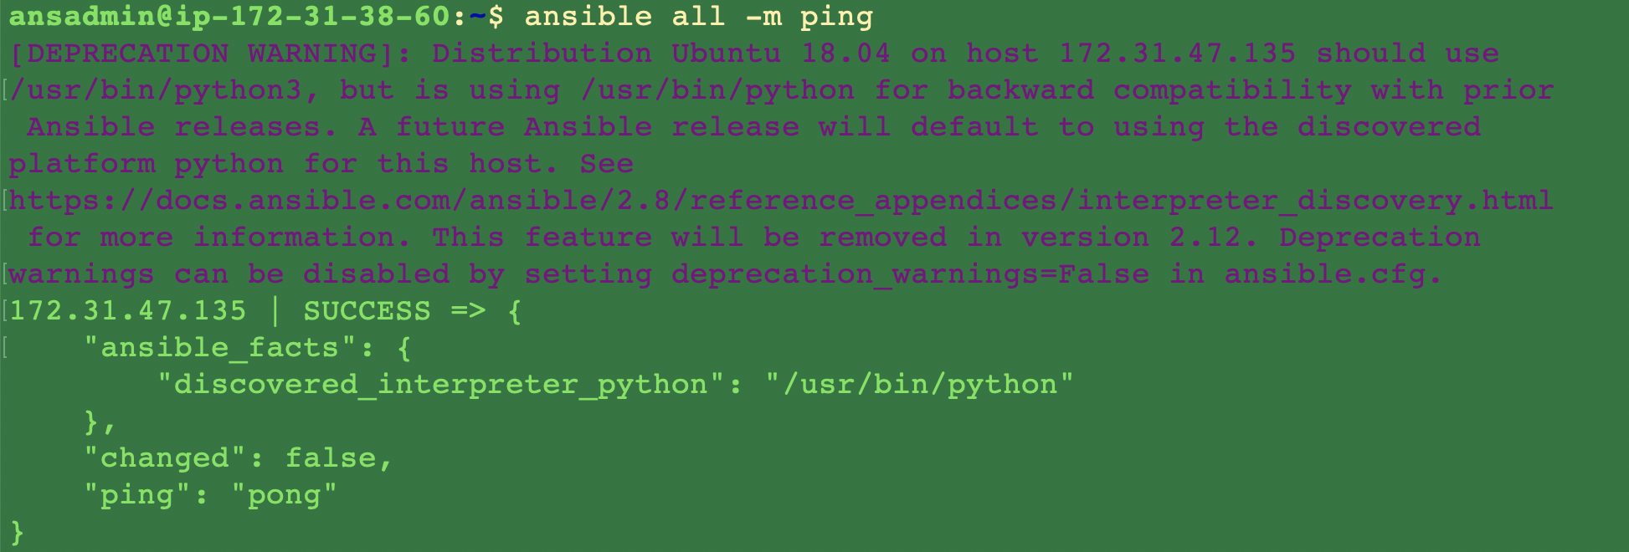

1. Add hosts to the inventory list



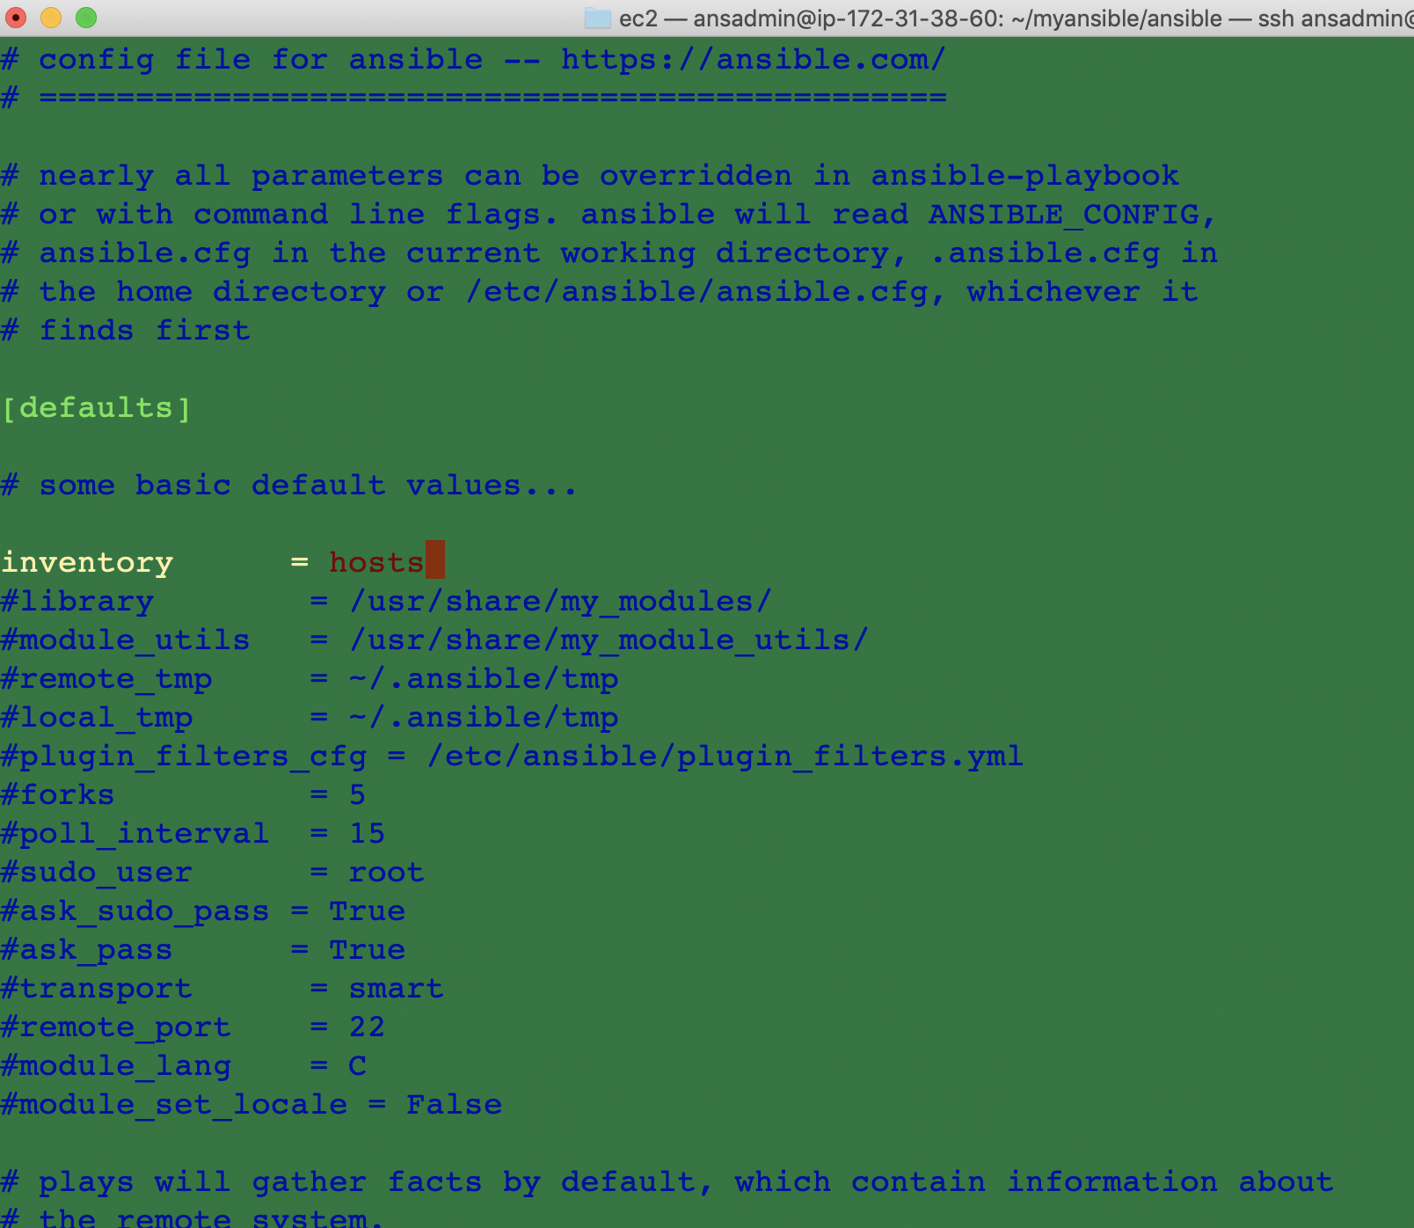

1. Create playbook vi myansible/ansible/playbook.yml

Playbook uninstalls apache if it’s already present, then installs apache and then verifies that apache is installed.

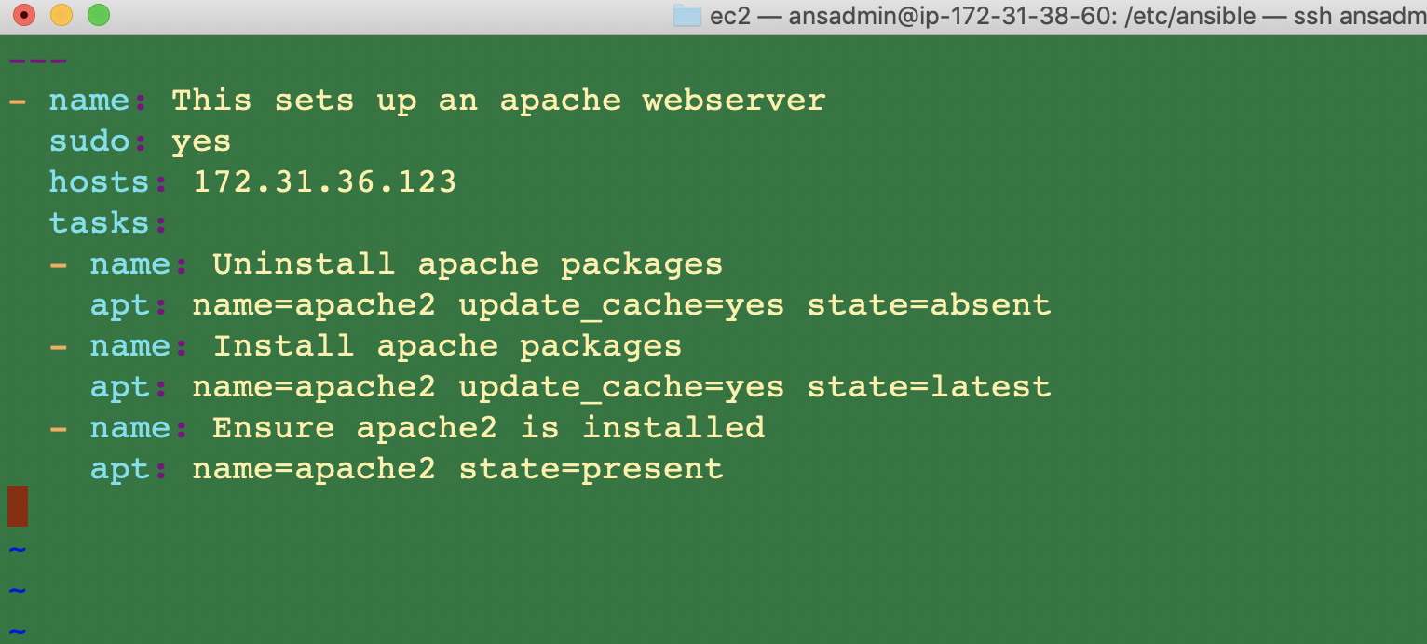

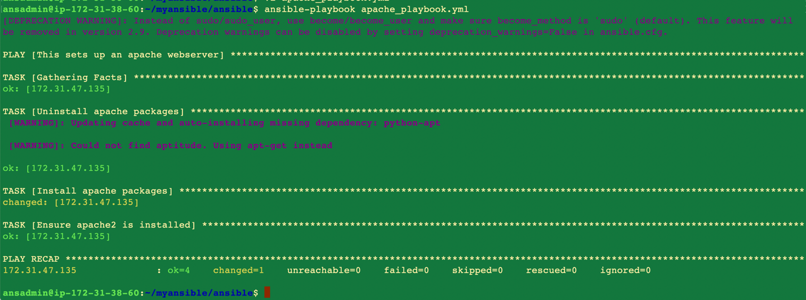

1. Check if apache is running on client

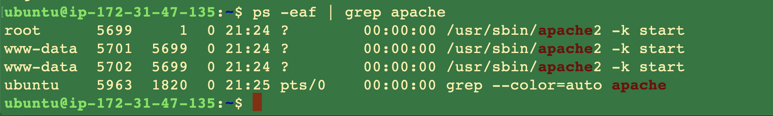

1. Update the index.html in client to display “Hello World”

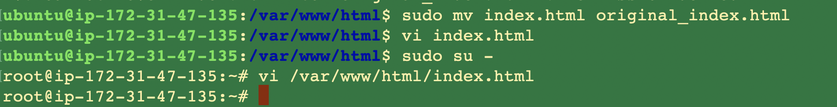

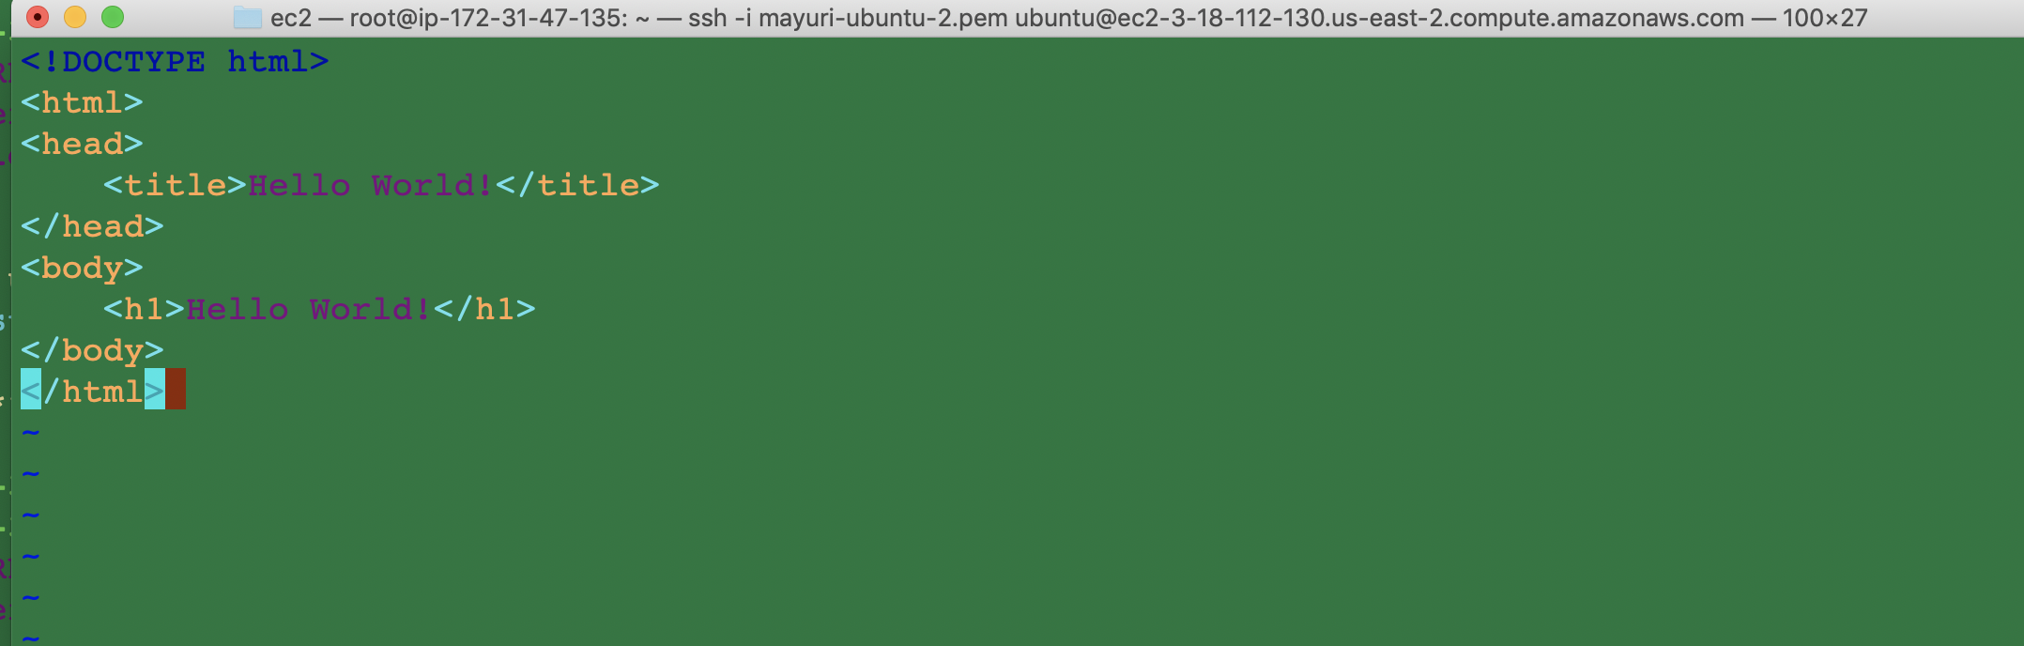

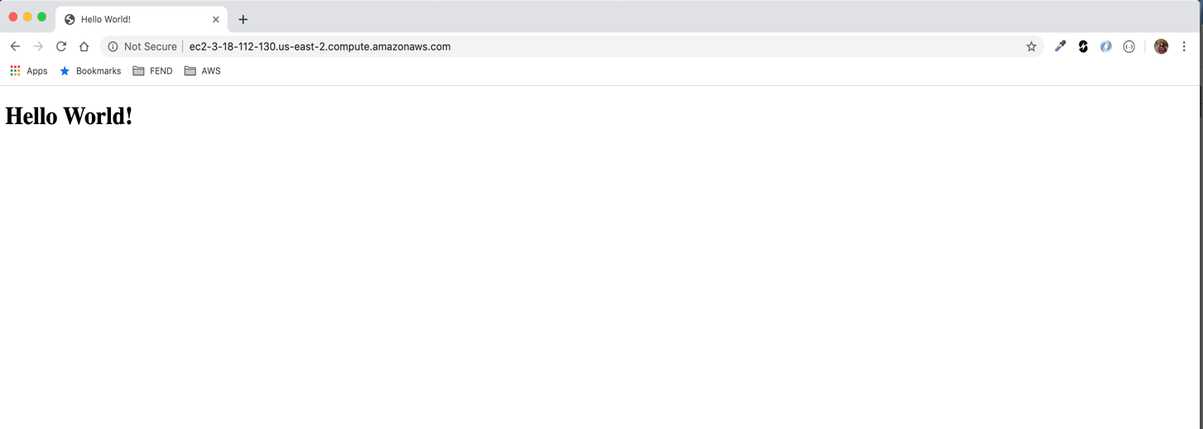

1. Undeploy Apache from client



1. Playbook for uninstall

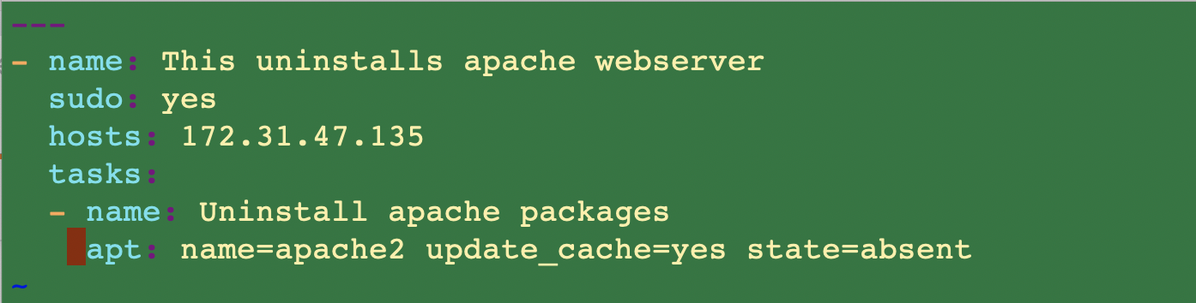

1. Execute command for undeploying

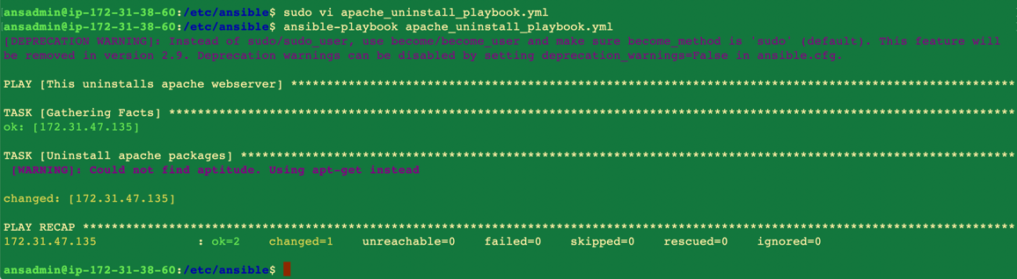

1. Check if apache is uninstalled

